**ShopSmart: Your Digital Grocery Store Experience**

**Team Details**

* **Team ID**: LTVIP2025TMID54300
* **Team Size**: 4
* **Team Leader:** Shaik Muzammil Hussain
* **Team Member:** Shaik Seeza Samreen
* **Team Member:** Shaik Abdul Hafeez
* **Team Member:** Shaik Irfan
* **Collage Name:** Vishnu Institute of Technology

**1.INTRODUCTION**

***1.1Project Overview***

ShopSmart is an innovative full-stack grocery web application aimed at revolutionizing the way customers interact with grocery stores. In today’s fast-paced digital world, consumers demand convenience, speed, and reliability — and ShopSmart delivers all three. The platform is designed to act as a one-stop solution for all grocery needs, allowing users to browse through a wide variety of products, search specific items, add them to a cart, and place orders — all from the comfort of their homes.

Built using the MERN stack (MongoDB, Express.js, React.js, and Node.js), the application is responsive, scalable, and secure. For customers, it offers a smooth and user-friendly interface to explore products categorized by types, brands, or popularity. For sellers and administrators, it provides a powerful backend dashboard to manage product listings, update stock, track orders, review customer feedback, and perform analytics for better decision-making.

By combining intuitive design with real-time functionality, ShopSmart ensures that both the buyer and the business owner experience a seamless digital interaction. It bridges the gap between traditional retail grocery and modern e-commerce expectations, making daily shopping effortless, organized, and digitally enabled.

***1.2 Purpose***

The primary purpose of the ShopSmart project is to transform the traditional grocery shopping process into a fully digitized and efficient experience. Physical grocery shopping often involves several drawbacks such as long queues, limited product availability, time-consuming billing, and manual inventory management. ShopSmart addresses these issues by offering an online alternative that is faster, smarter, and more accessible.

Through this application, we aim to:

* **Enhance convenience** by allowing users to shop anytime, anywhere.
* **Eliminate human error** in order handling and stock updates.
* **Provide real-time inventory visibility** to customers and sellers.
* **Support sellers** with tools to manage products, analyze sales trends, and engage with customers.
* **Ensure data security and privacy**, with protected user sessions and secure payments.
* **Enable role-based access** for users, admins, and sellers to ensure proper functionality and control.

Ultimately, the project’s mission is to make grocery shopping an effortless task for customers and a streamlined operation for store owners — paving the way for smarter retail in the digital era.

**2. Ideation Phase**

***2.1 Problem Statement***

When we started thinking about building a project, we looked around us and realized that grocery shopping something so essential still has many pain points for both customers and shopkeepers. Most people still depend on physical stores, which often leads to long queues, unavailable items, and poor communication about stock or delivery. Similarly, for shop owners, manually managing inventory and orders can be tiring and error-prone.

That’s when the idea of ShopSmart was born a digital grocery shopping platform that works in real-time and helps both customers and sellers manage their needs more efficiently.

***2.2 Empathy Map Canvas***

To better understand the people we were building this for, we created an empathy map. Here's what we found:

* **Who?**

The two main users are everyday customers and grocery store owners/admins.

* **What do they Think & Feel?**

Customers are often annoyed by waiting in lines or not finding the products they want. Shop owners want things to be more organized but don’t always have the tools.

* **What do they See?**

They see chaotic shelves, handwritten bills, and no clear system to track orders or stock.

* **What do they Say & Do?**

Customers often ask for home delivery or complain when something is out of stock. Sellers try their best but struggle to keep everything updated.

* **What do they Hear?**

There’s a growing buzz about online shopping and digital stores many say it’s time to upgrade.

* **What’s their Pain?**

Time gets wasted, there’s no transparency, and managing things manually is exhausting.

* **What do they Gain if solved?**

A system like ShopSmart would bring them convenience, save their time, and give them better control whether they're buying or selling.

***2.3 Brainstorming***

At the start, we thought about keeping it simple maybe just a basic product listing website. But as we discussed further, we realized how much more useful the platform could be if we built it the right way.

We brainstormed over:

* Giving customers a full shopping experience with cart, order tracking, and feedback
* Creating a separate admin dashboard for store owners to manage inventory and orders
* Adding secure login, user roles, and categories
* Designing a clean, mobile-friendly interface

That’s how our idea evolved into ShopSmart, a complete and practical grocery web application that covers everything from browsing to buying, managing to delivering.

**3. Requirement Analysis**

***3.1 Customer Journey Map***

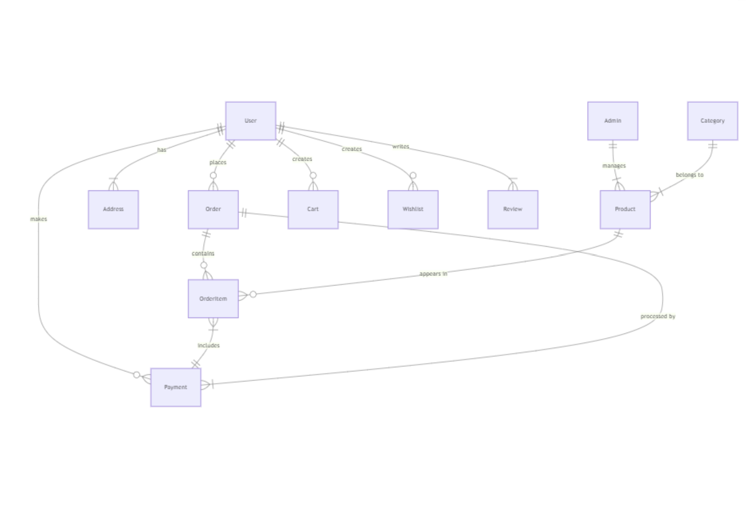***3.2 Solution Requirements***

* User Authentication
* Product Browsing & Details
* Shopping Cart & Checkout Flow
* Admin Dashboard for Inventory Management
* Order Tracking & History
* Feedback Collection

**3.3 Data Flow Diagram**

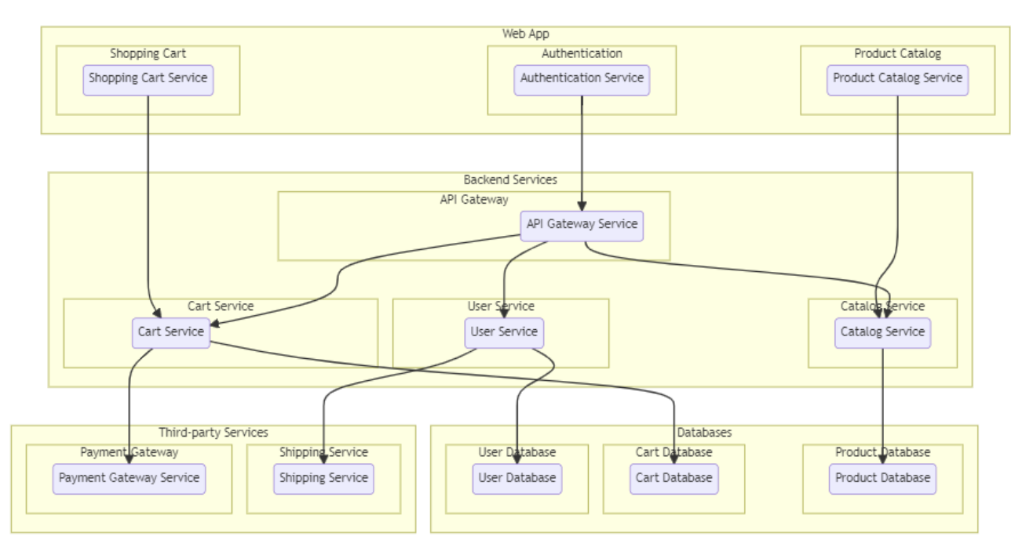

***3.4 Technology Stack***

* **Frontend**: React.js
* **Backend**: Node.js, Express.js
* **Database**: MongoDB
* **Authentication**: JWT
* **Styling**: Bootstrap, CSS
* **Version Control**: Git + GitHub

**4. Project Design**

***4.1 Problem-Solution Fit***

In today's fast-paced world, traditional grocery shopping methods often prove to be time-consuming, inefficient, and stressful for both customers and sellers. Customers frequently face challenges such as long queues, limited product availability, unclear pricing, and lack of real-time information. On the other hand, sellers struggle with manually managing inventory, tracking orders, and responding to customer needs in a timely manner.

**ShopSmart** addresses these issues by creating a digital bridge between traditional shopping habits and modern-day convenience. The application enables customers to shop for groceries from the comfort of their homes while giving sellers a powerful yet user-friendly platform to manage their store operations. It eliminates the need for physical store visits and simplifies the entire shopping experience by offering real-time inventory updates, smooth ordering processes, and easy communication between users and administrators. The app is designed to be intuitive and accessible, removing technical barriers for users of all backgrounds.

***4.2 Proposed Solution***

We implemented two separate portals:

To provide a complete and efficient online grocery shopping experience, **ShopSmart** has been designed with two separate portals catering to the specific needs of customers and administrators:

**1. Customer Portal**

This portal is tailored for end-users (customers) and focuses on ease of use and a seamless shopping experience. Key functionalities include:

* **User Registration and Login**: Secure authentication using JWT tokens.
* **Product Browsing**: View products categorized by type (e.g., fruits, vegetables, dairy, snacks) with detailed information such as name, price, description, and image.
* **Cart Management**: Add, remove, and update items in the shopping cart.
* **Order Placement**: Place orders with selected items and receive order confirmations.
* **Order History**: Track and view past orders for easy reordering.
* **Feedback Submission**: Share reviews or feedback to improve the platform.
* **Responsive UI**: Mobile-friendly design for convenient shopping on any device

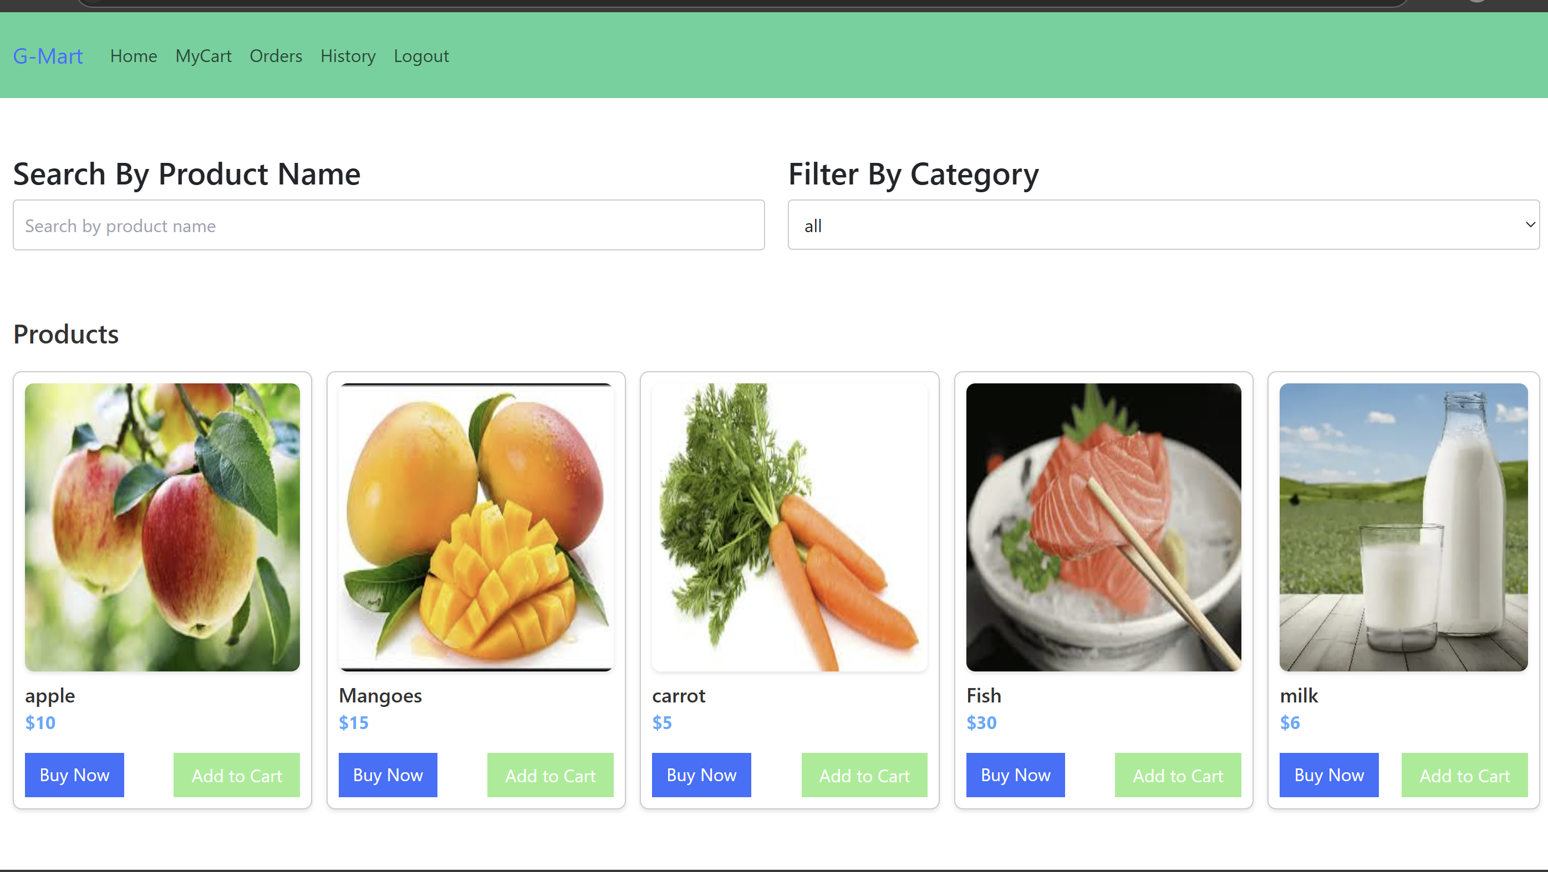

**2. Admin Portal**

This portal is designed for sellers or store managers to handle operations efficiently. It provides complete control over the e-commerce backend with the following features:

* **Admin Authentication**: Secure login to restrict access to authorized users.
* **Product Management**: Add new products, edit existing ones, or delete discontinued items.
* **Category Management**: Create and update product categories to keep the storefront organized.
* **Order Management**: View incoming orders, update their statuses (e.g., pending, shipped, delivered), and manage order logistics.
* **User Management**: View registered users and manage access or activity as needed.
* **Feedback Monitoring**: Review customer feedback to make improvements or address concerns.
* **Dashboard Insights**: Visual representation of key metrics such as number of products, total orders, and user activity.

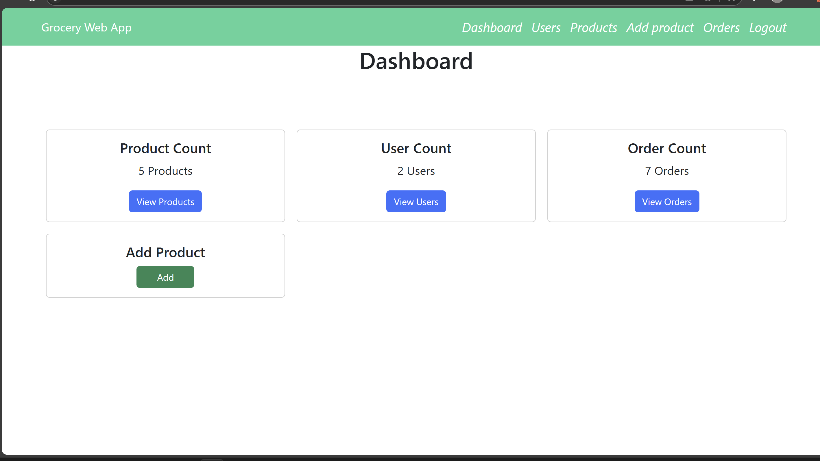

***4.3 Solution Architecture***

The ShopSmart application is built using a three-tier architecture that consists of the **frontend**, **backend**, and **database** layers. Each component is responsible for handling specific parts of the system’s functionality, ensuring modularity, scalability, and maintainability.

**Frontend (React.js)**

The frontend is developed using **React.js**, a popular JavaScript library for building dynamic and responsive user interfaces. It acts as the **presentation layer** of the application and is responsible for:

* Displaying products, categories, user information, cart contents, and order status
* Managing client-side routing and state using tools like React Router and Context API or Redux
* Sending HTTP requests (via Axios or Fetch API) to the backend for tasks such as logging in, adding items to the cart, placing orders, submitting feedback, etc.
* Receiving and rendering responses from the backend to provide real-time interactivity and a seamless user experience
* Supporting both **user** and **admin** interfaces, where the admin dashboard includes product management, order tracking, and feedback review functionalities

**Backend (Node.js + Express.js)**

The backend is implemented using **Node.js** with the **Express.js** framework, which provides a fast and lightweight platform for building RESTful APIs. This acts as the **business logic and application layer**, and is responsible for:

* Authenticating users and admins using JWT (JSON Web Tokens)
* Validating and processing incoming requests from the frontend
* Handling CRUD operations for products, users, categories, carts, and orders
* Communicating with the MongoDB database to retrieve and manipulate stored data
* Implementing secure APIs for login, registration, cart operations, placing orders, viewing order history, managing inventory, and collecting feedback
* Logging and error handling to ensure robust and fault-tolerant backend operations

**Database (MongoDB)**

The application uses **MongoDB**, a NoSQL document-based database, to store and manage all data. It serves as the **data layer** of the architecture and is designed to support flexible, scalable, and high-performance data storage. Key responsibilities include:

* Storing structured data in collections such as Users, Products, Categories, Orders, Carts, and Feedback
* Enabling quick retrieval and updates of user information, product listings, order details, and feedback
* Supporting relationships between documents using referencing and embedded documents where necessary
* Allowing horizontal scaling and replication for future growth and reliability

**Workflow Summary**

1. The user interacts with the React.js frontend (e.g., adds items to cart, places an order).
2. The frontend sends an HTTP request to the backend API.
3. The Express server processes the request, communicates with the MongoDB database if needed, and sends a response back.
4. The frontend receives the response and updates the UI accordingly.

**5. Project Planning & Scheduling**

***5.1 Project Planning***

To ensure efficient development and timely completion of the ShopSmart application, the project was broken down into well-defined phases, each focusing on specific core functionalities. This systematic planning helped in streamlining the workflow, tracking progress, and ensuring seamless integration of all components.

The overall development process included the following major stages:

* **Frontend Initialization and UI Design**

The project began with setting up the React.js environment and designing a user-friendly interface for both the customer and admin portals. Initial efforts were focused on building reusable components, responsive layouts, and intuitive navigation.

* **Backend development with Express and MongoDB**

Following the UI setup, the backend was developed using Node.js and Express.js. MongoDB was integrated for storing user data, product details, orders, and feedback. RESTful APIs were created to handle data transactions between the frontend and backend.

* **Cart and Checkout Functionality Implementation**

Once the basic structure was ready, cart operations were implemented. Users could add items to their cart, update quantities, remove products, and proceed to checkout. Order placement and confirmation mechanisms were also developed in this phase.

* **Authentication and Route Protection**

JWT-based authentication was implemented to manage secure login for both users and admins. Role-based access control was established to protect sensitive routes and ensure that only authorized users could perform specific actions.

* **Admin Panel Development**

The admin dashboard was built with functionalities to manage products, categories, orders, users, and feedback. This interface provides admins with complete control over store operations in a visually organized manner.

* **Testing and Deployment Preparation**

Finally, the application underwent functionality testing, bug fixing, and performance optimization. Necessary configurations were made for deployment, ensuring the system was stable, scalable, and production-ready.

**6. Functional & Performance Testing**

***6.1 Performance Testing***

To ensure that the ShopSmart application delivers a smooth and efficient user experience, we conducted thorough performance testing across key scenarios. Our goal was to validate not only the system’s speed and responsiveness but also its ability to handle essential operations seamlessly.

Here are the key areas we focused on:

* **Fast Page Load Times**

We prioritized ensuring that all major pages — including the homepage, product listing, cart, and checkout — loaded quickly. By optimizing assets, reducing unnecessary re-renders, and using efficient state management in React, we were able to keep the average page load time **under 2 seconds**, providing a responsive and user-friendly experience even on moderate internet connections.

* **Optimized API Responses**

The APIs responsible for critical operations such as **cart management** and **order placement** were tested for performance and efficiency. We ensured that database queries were optimized, response payloads were kept minimal, and endpoints were designed to handle real-time updates. As a result, the system could process add-to-cart and order-related actions within milliseconds, enhancing the overall shopping experience.

* **Real Time Admin Panel Operations**

Special attention was given to the **admin dashboard**, where administrators perform actions like adding, editing, or deleting products and categories. These **CRUD operations** were tested extensively to ensure changes were **instantly reflected** in the frontend without requiring manual refreshes, enabling a real-time management experience for store administrators.

* **Secure and Efficient Route Protection**

All **protected routes and sensitive operations** — such as accessing the admin panel, managing orders, or updating user data — were validated using **JWT-based authentication**. We tested scenarios involving token expiration, invalid tokens, and unauthorized access attempts to ensure that only verified users could access protected content, without compromising on performance.

**7. Results**

**7.1 Output Screenshots**

* Home Page with product categories

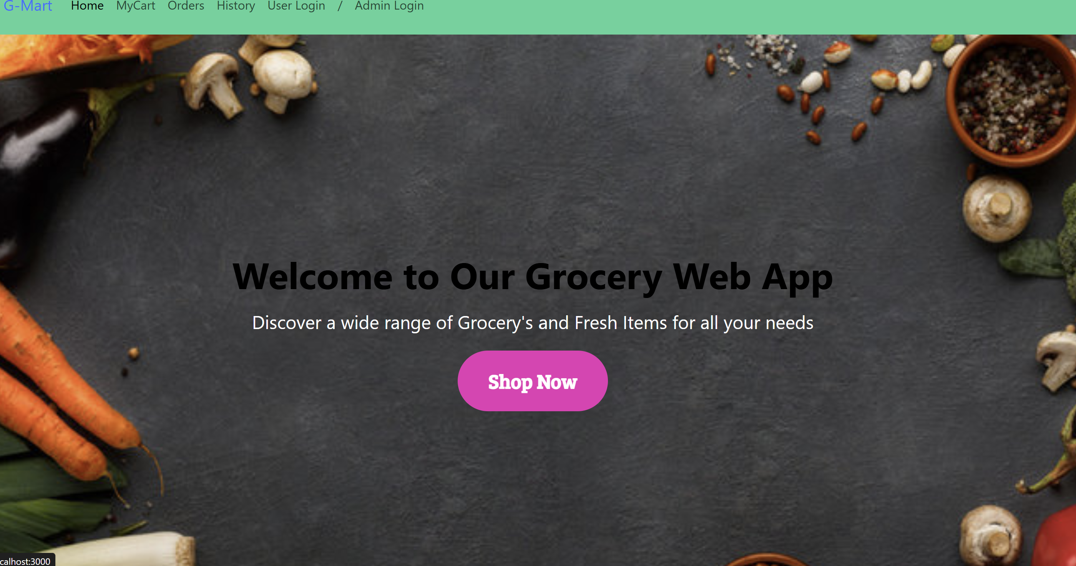

* Login/Signup screens

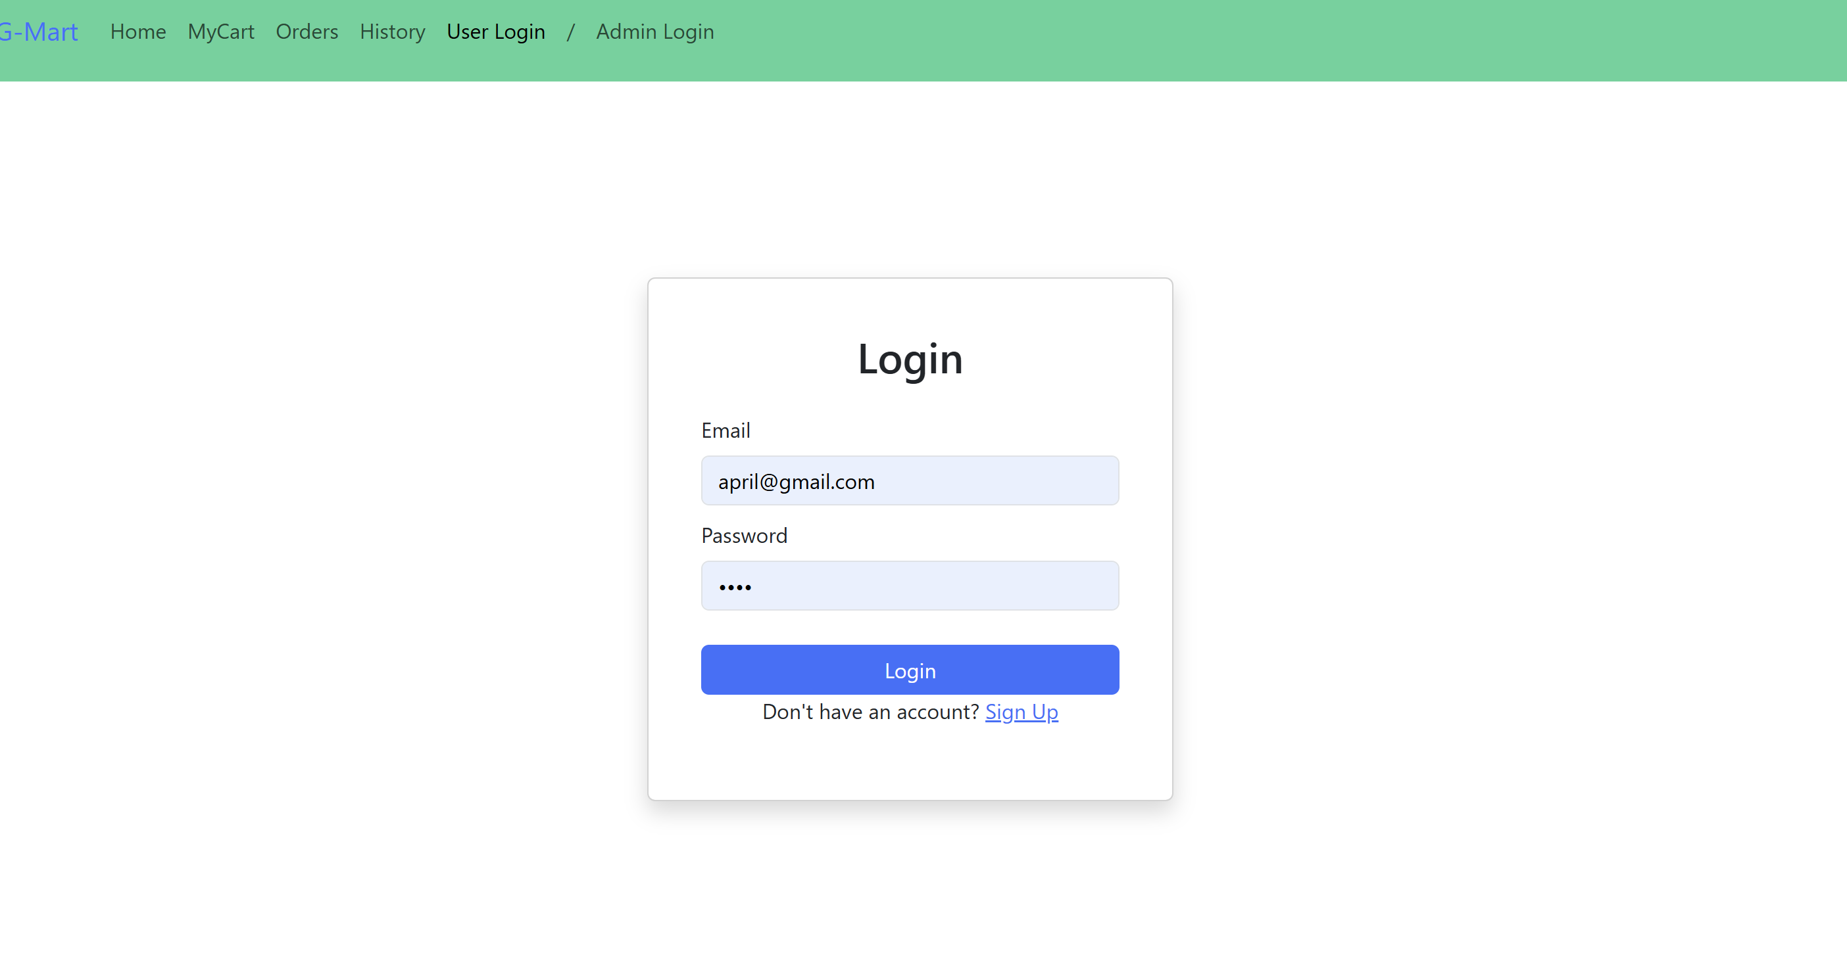

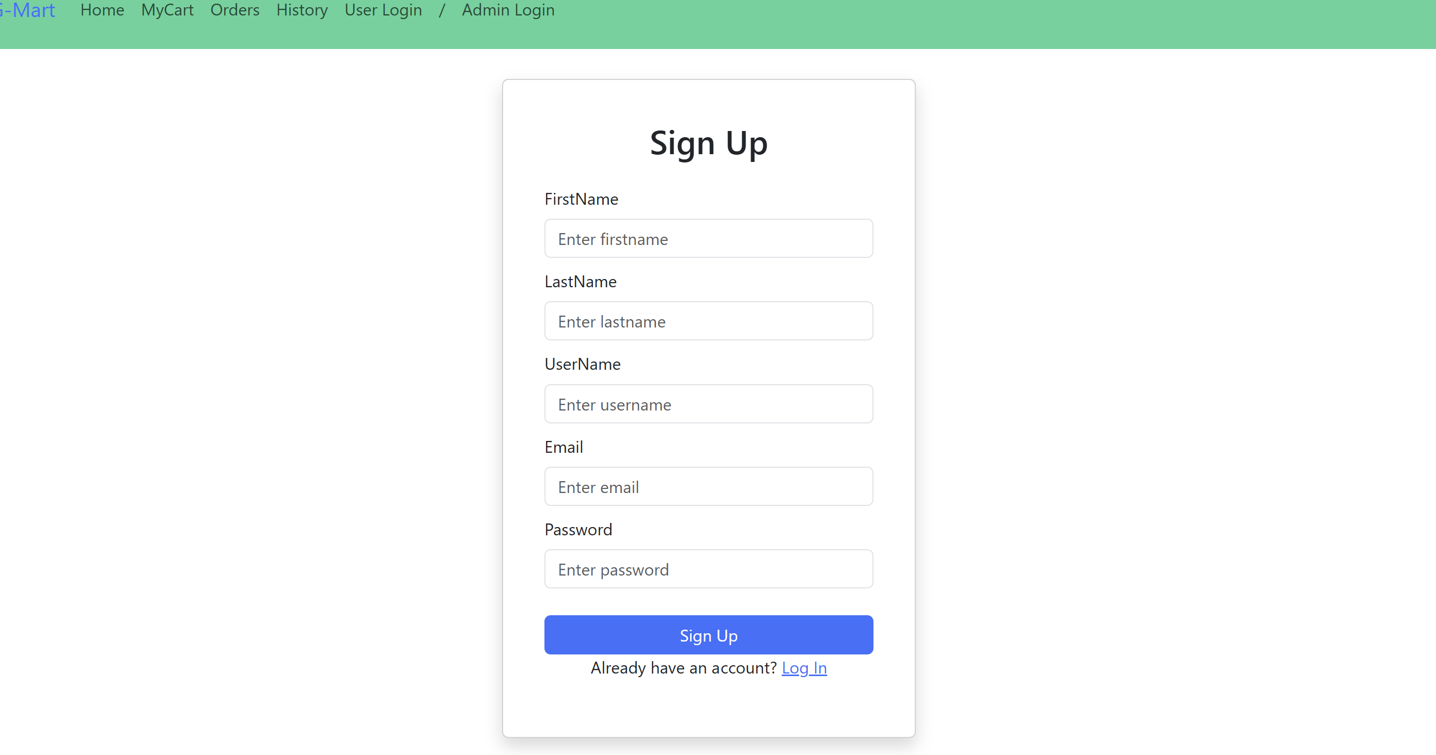

* Product details view

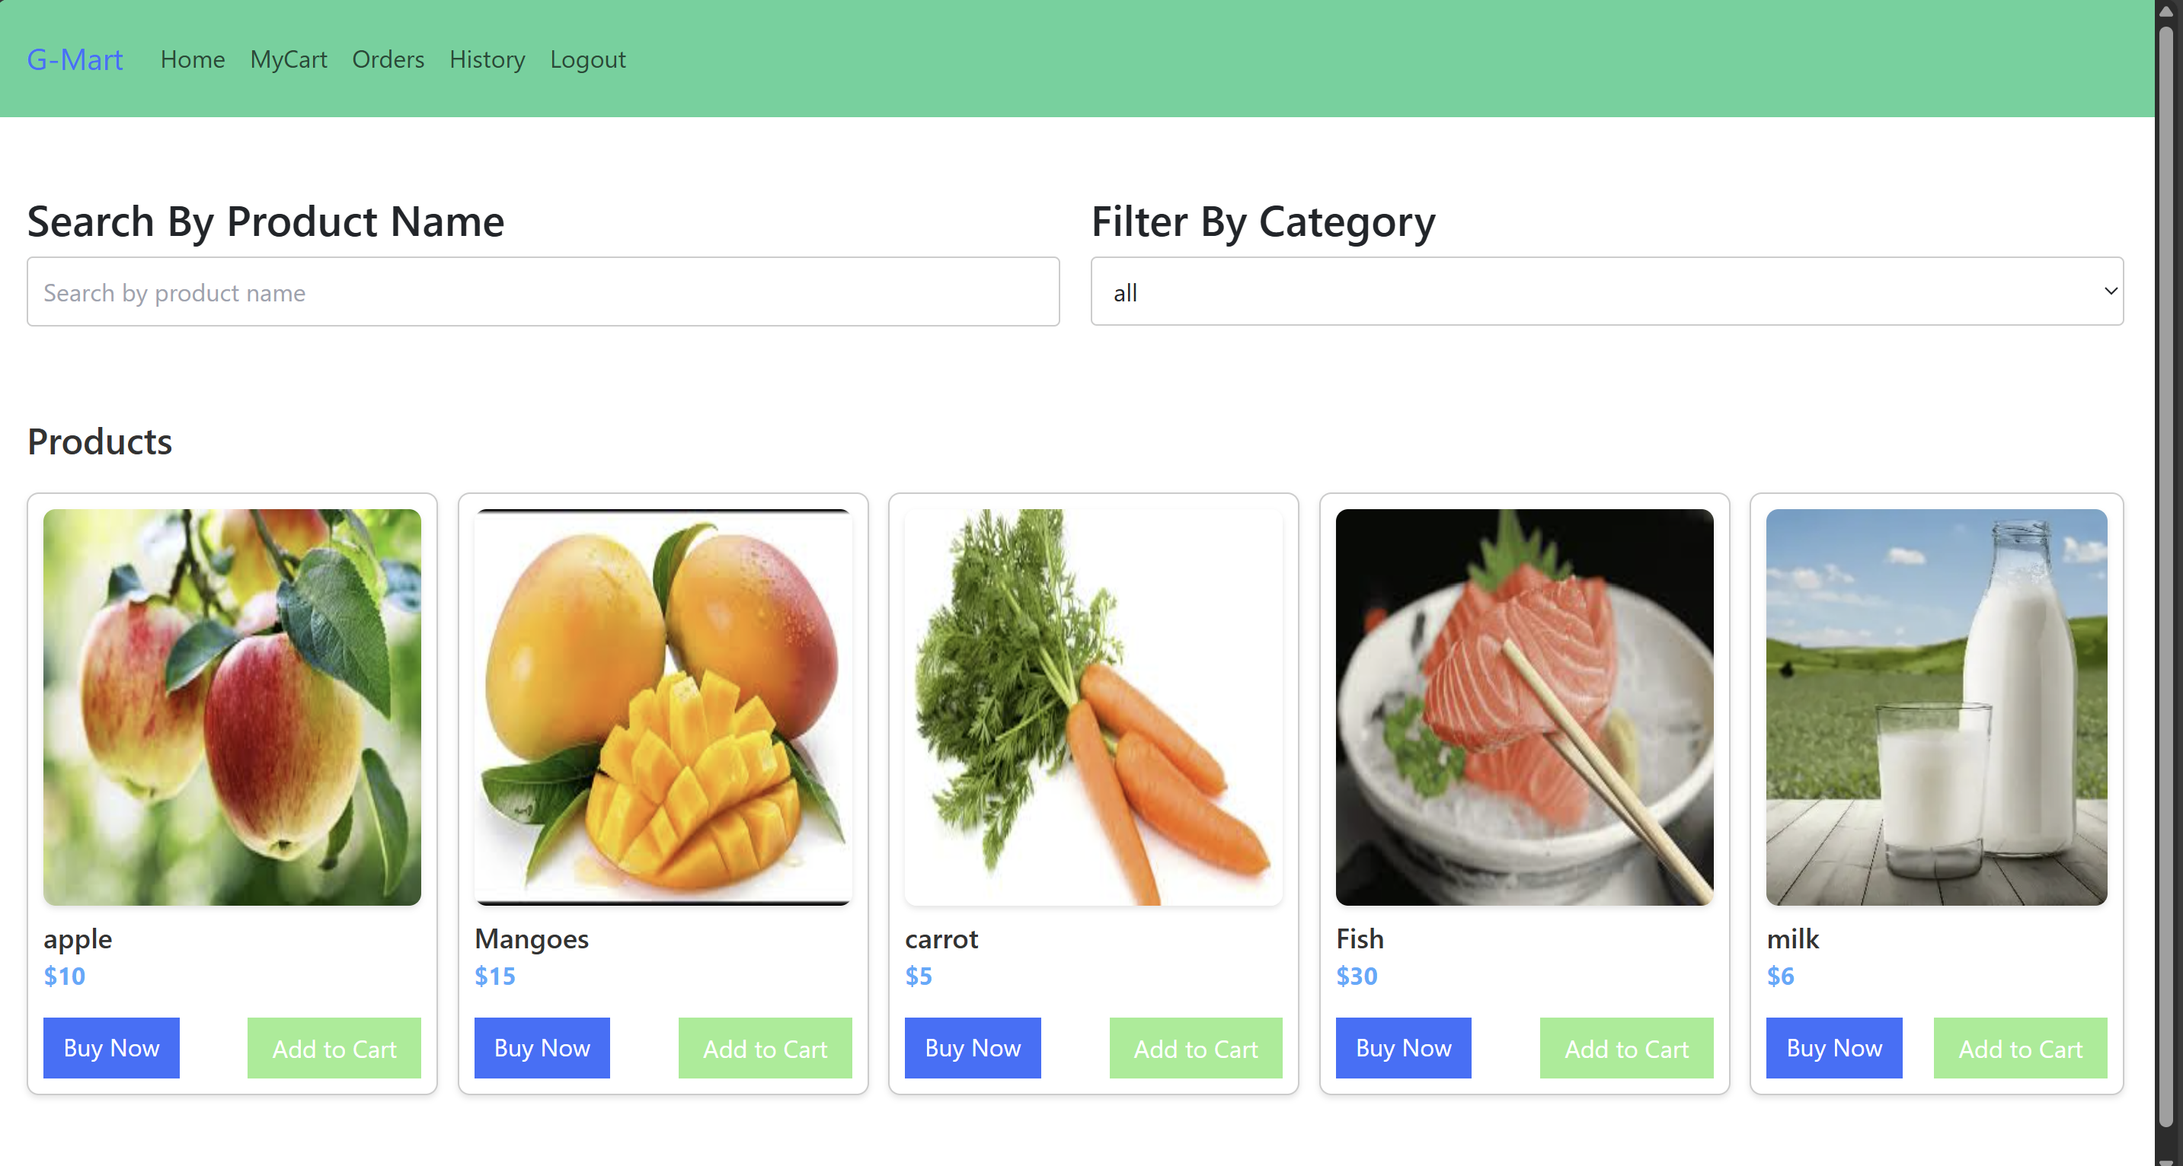

* Cart & checkout

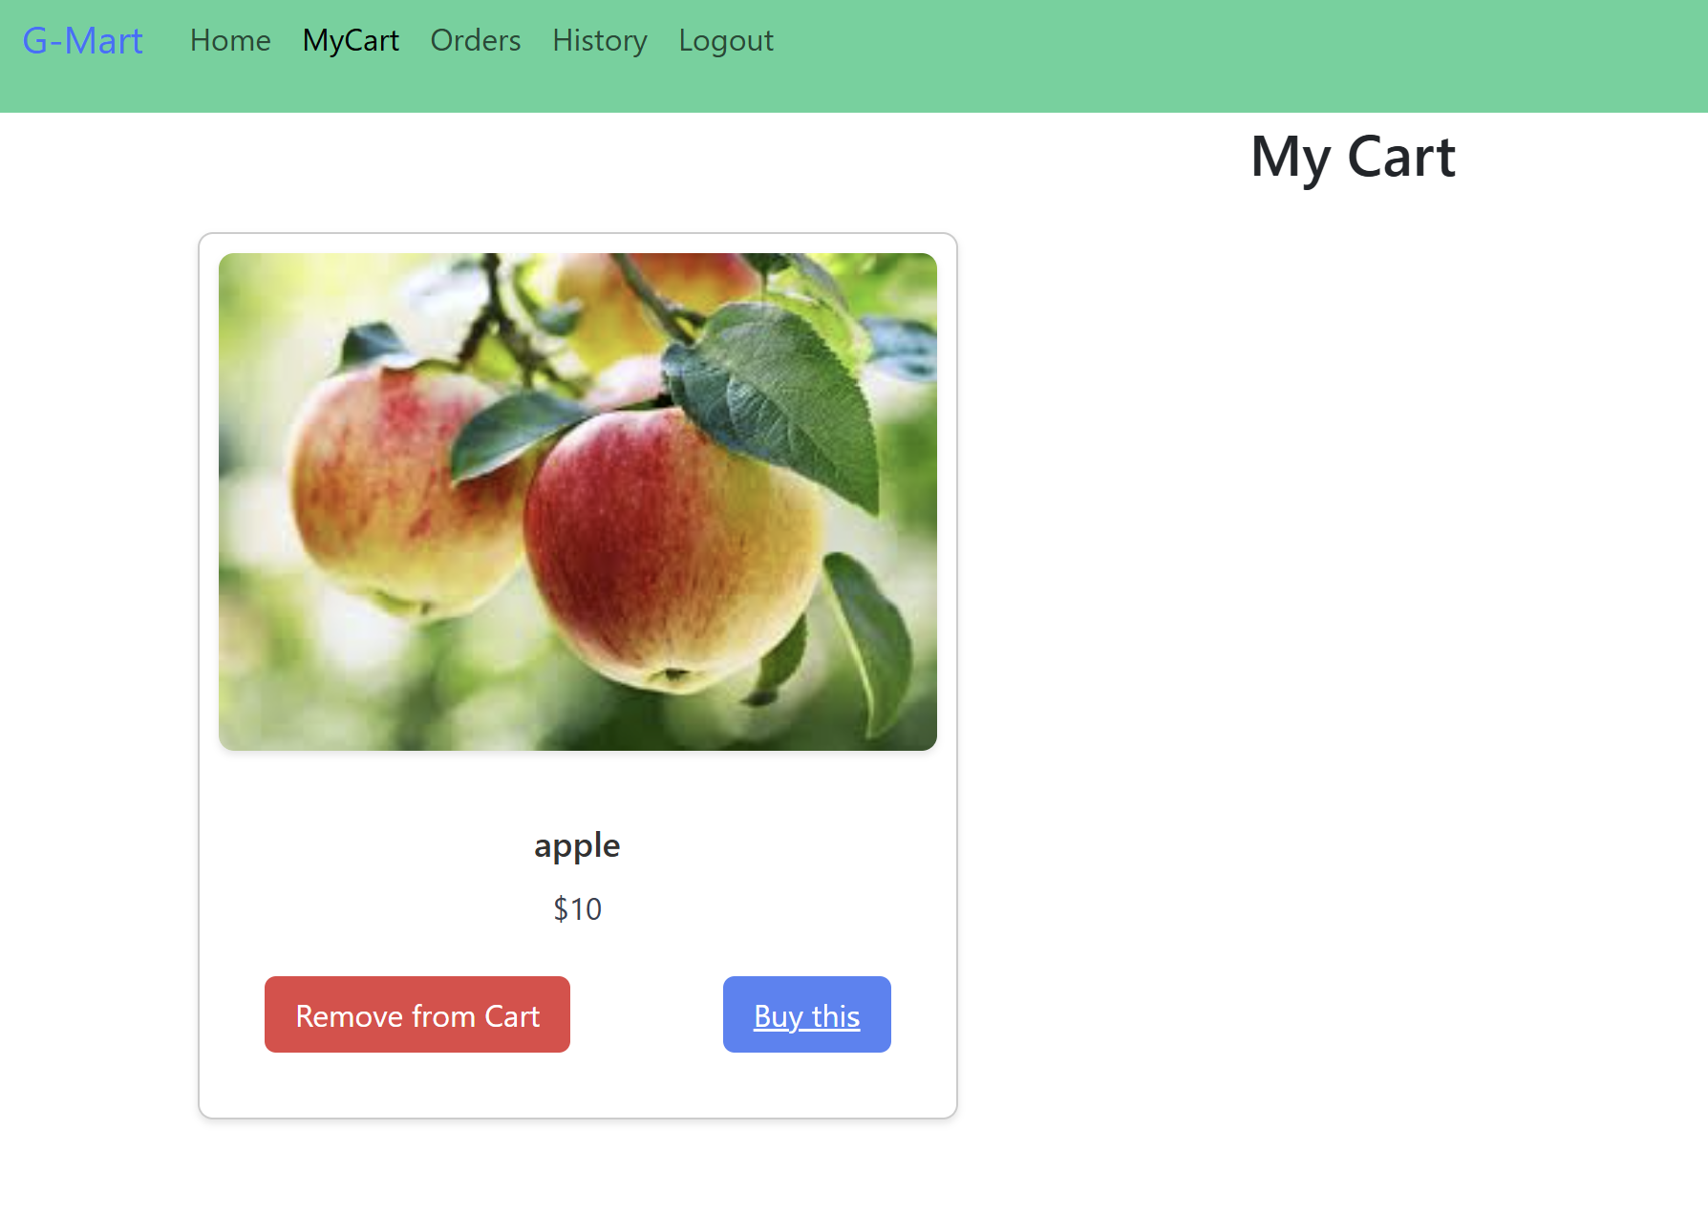

* Admin dashboard

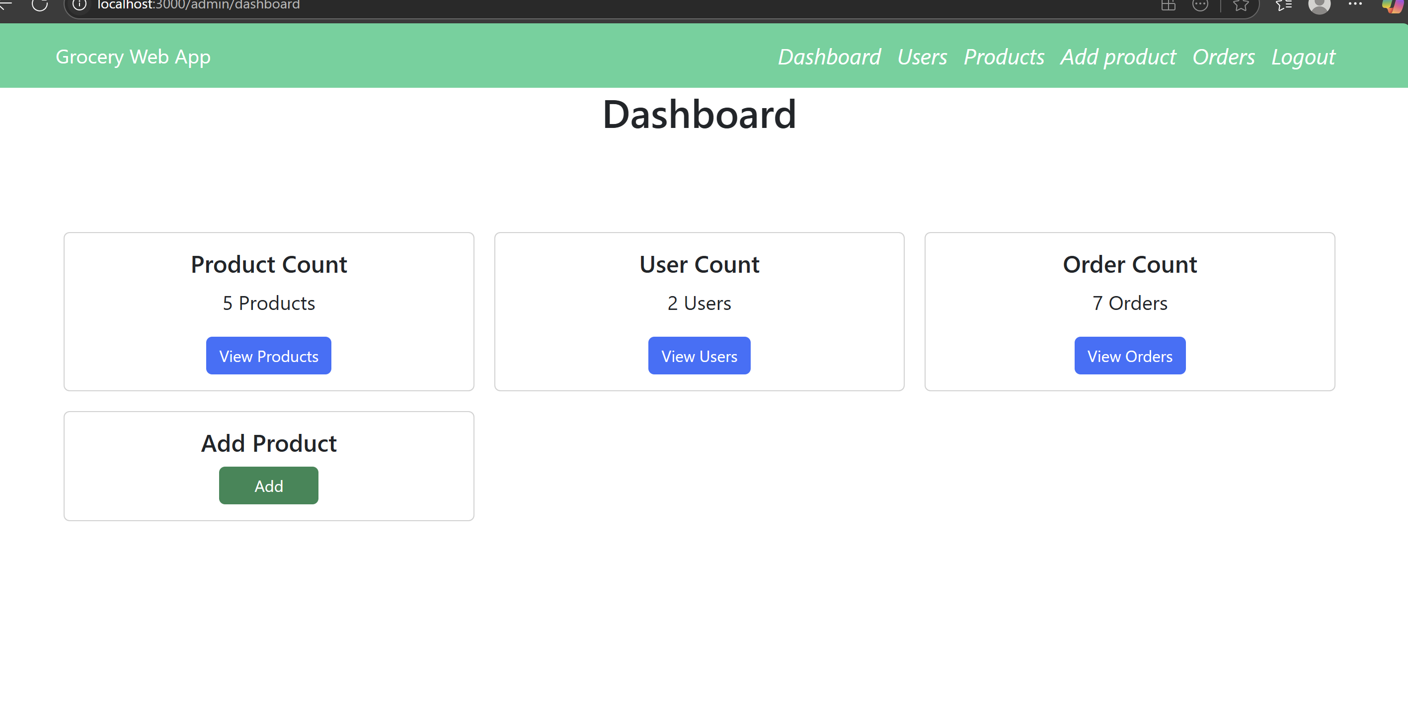

* Order history

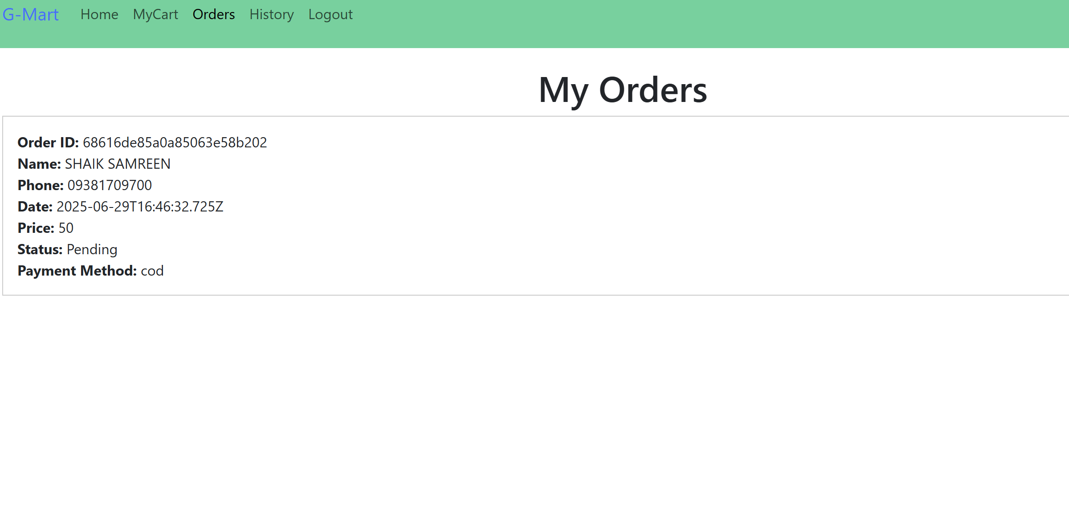

**8. Advantages & Disadvantages**

**✅ Advantages**

* **Intuitive and Responsive Design**
* The application features a clean and user-friendly interface built with React.js. It ensures a seamless experience across desktops and most tablets, making it easy for users to browse products, manage their cart, and place orders with minimal effort**.**
* **Separate panels for Admins and Users**

By implementing distinct interfaces for customers and administrators, the application ensures that each user type has access to only the features they need. This separation enhances usability, maintains security, and simplifies management tasks for store owners.

* **Secured with JWT Authentication**

The use of JSON Web Tokens (JWT) helps in securely managing user sessions. Sensitive routes and data are protected, ensuring only authorized users can access specific features like order history (for users) and inventory management (for admins).

* **Scalable and Maintainable Architecture**

Built with modern technologies like React, Node.js, and MongoDB, the project follows a modular architecture. This makes it easy to scale the application in the future — whether by adding new features, expanding to new user bases, or integrating third-party services.

**Disadvantages**

* **No real time Delivery tracking**

At present, the system lacks integration with real-time delivery tracking features (like GPS tracking or live order status updates). Customers can only view static order statuses, which limits visibility into the delivery process.

* **Requires Constant Internet Connectivity**

As a web-based application, ShopSmart relies on uninterrupted internet access. Users cannot access or use the platform offline, which may be a limitation in areas with poor or unstable connectivity.

* **Mobile Optimization not yet completed**

Although the application is responsive to an extent, full mobile optimization is still under development. Some features or layouts may not render perfectly on smaller screens, affecting usability for mobile-first users.

**9. Conclusion**

**ShopSmart** is more than just a web application it's a step toward transforming the way we approach grocery shopping in the digital age. By blending modern technologies with a user-centric design, ShopSmart successfully bridges the gap between traditional shopping hassles and the expectations of today’s fast-paced, convenience-driven world.

For **customers**, it offers a smooth and stress-free shopping experience. From browsing products to placing orders and tracking past purchases, everything can be done with just a few clicks anytime, from anywhere. The intuitive interface, secure login, and fast responses make it easy for users of all ages and technical abilities to use the platform confidently.

For **store owners and admins**, ShopSmart provides complete control over their online store. With features like product and category management, order tracking, and feedback monitoring, administrators can efficiently run their operations without the need for complex systems or technical know-how. Real-time updates and secure admin access ensure reliability and smooth functioning.

Overall, ShopSmart is a well-rounded, scalable, and secure solution tailored to meet the needs of both shoppers and sellers. It simplifies everyday grocery transactions, saves time, and brings the entire store into the palm of your hand all while laying a strong foundation for future enhancements like mobile apps and real-time delivery tracking.

With continued improvements, ShopSmart holds the potential to become a go to platform for digital grocery shopping in communities, businesses, and beyond.Top of Form

Bottom of Form

**10. Future Scope**

While ShopSmart already delivers a solid foundation for digital grocery shopping, there’s tremendous potential for growth and enhancement. As user needs evolve and technology advances, the platform can be further enriched with new features to provide an even more seamless, intelligent, and convenient shopping experience. Below are the key areas we envision expanding in the future:

**💳 Integration of Online Payment Gateways**

To improve the checkout experience, we plan to integrate secure and widely-used online payment gateways like **Stripe** and **Razorpay**. This will allow customers to pay directly via credit/debit cards, UPI, or net banking, offering a hassle-free and trustworthy transaction process right from the platform.

**📱 Mobile Application for iOS and Android**

To increase accessibility and reach a broader audience, we aim to build a fully functional mobile application using **React Native**. A dedicated mobile app will allow users to shop on-the-go, receive real-time updates, and enjoy a more personalized experience tailored for smaller screens.

**🚚 Real-Time Delivery Tracking**

A major enhancement will be the addition of **real-time delivery tracking**. Customers will be able to monitor the live status of their orders using GPS-based tracking, making the delivery process more transparent and reducing uncertainty about arrival times.

**📩 WhatsApp and SMS Notifications**

To keep users informed at every step of their order journey, we plan to introduce **automated WhatsApp and SMS alerts**. These notifications will include updates like order confirmation, dispatch status, expected delivery time, and promotional offers — making the user experience more interactive and connected.

**🧠 AI-Powered Product Recommendation Engine**

By integrating **AI and machine learning**, the platform can analyze customer behavior, preferences, and past purchases to suggest relevant products. This personalized recommendation engine will enhance product discovery, improve sales for sellers, and create a more engaging shopping experience for users.

**📊 Role-Specific Dashboards and Analytics**

To empower both customers and admins with data, we plan to build **custom dashboards**.

* **Admins** will benefit from detailed analytics on product performance, user behavior, sales trends, and inventory management.
* **Customers** can track their order history, spending patterns, and receive personalized insights — making shopping smarter and more efficient.

**11. Appendix**

* **GitHub Repository:** <https://github.com/Samreen-Shaik/SHOP-SMART>

